 | SRI KRISHNA COLLEGE OF  ENGINEERING AND TECHNOLOGY  (An Autonomous Institution)  (Approved by AICTE and Affiliated to Anna University, Chennai)  ACCREDITED BY NAAC WITH “A” GRADE | 
DUAL AXIS INTENSITY BASED SOLAR TRACKING SYSTEM

A MINI PROJECT I REPORT

Submitted by
D.GOBINATH (16EUEE037)
S.HARIBALAJI (16EUEE043)
N.GOKUL (16EUEE039)

In partial fulfillment of the requirements
for the award of the degree
of

BACHELOR OF ENGINEERING
IN
ELECTRICAL AND ELECTRONICS ENGINEERING

APRIL-2018

SRI KRISHNA COLLEGE OF ENGINEERING AND TECHNOLOGY
(An Autonomous Institution)
(Approved by AICTE and Affiliated to Anna University, Chennai)
ACCREDITED BY NAAC WITH “A” GRADE

BONAFIDE CERTIFICATE

Certified that the project report “DUAL AXIS INTENSITY BASED SOLAR TRACKING SYSTEM” is the bonafide work of N.GOKUL(16EUEE039), D.GOBINATH(16EUEE037) , S.HARIBALAJI(16EUEE043) who carried out the project work under my supervision.

MS.N.SUBHASHINI
SUPERVISOR
ASSISTANT PROFESSOR
Department of Electrical and Electronics Engineering,
Sri Krishna College of Engineering and Technology, Coimbatore-641008

Dr. K. LAKSHMI, M.E., PH.D.,
HEAD OF THE DEPARTMENT
Department of Electrical and Electronics Engineering,
Sri Krishna College of Engineering and Technology, Coimbatore-641008

This project report submitted for the Autonomous Mini Project Viva-voce examination held on____________

INTERNAL EXAMINER EXTERNAL EXAMINER

DECLARATION

We affirm that the project titled “DUAL AXIS INTENSITY BASED SOLAR TRACKING SYSTEM” is being submitted in partial fulfillment for the award of BACHELOR OF ENGINEERING (B.E.) is the original work carried out by us. It has not formed the part of any other project submitted for award of any degree or diploma, either in this or other university.

Signature of the candidates

I certify that the declaration made above by the candidate is true .

Signature of the Guide
ACKNOWLEDGEMENT
We would like to thank the management for supporting us during our entire project and encouraging us to be innovative and backing us in everything we did.
We would like to thank our Principal Dr.J. JANET, for allowing us to do this project and providing required time to complete the same.
We express our sincere thanks to our beloved Head of the Department, Dr. K.LAKSHMI for her encouragement in our endeavor.
We deem it our duty, our sincere admiration and heartfelt gratitude to our project guide Assistant Professor MS.N.SUBHASHINI , for having effectively guided and supervised throughout this project by imparting her erudite knowledge and personalized guidance blended with exemplary patience and encouragement.
We are grateful to MR. MAIDEEN ABDHULKADHER JEYLANI, Assistant professor, Department of Electrical and Electronics Engineering, our project coordinator, for his profound ideas and invaluable guidance.
We thank all the teaching faculty of our department for their constant encouragement and support during the project.
We express our sincere thanks to all the laboratory assistants for helping us in completing the project.
Finally, we would like to take this opportunity to thank our family members, friends, well-wishers who have helped us for the successful completion of the project.

TABLE OF CONTENTS
CHAPTER NO. TITLE PAGE NO.

ABSTRACT iii
LIST OF TABLE xvi
LIST OF FIGURES xviii
LIST OF SYMBOLS xxvii
1. INTRODUCTION 1
1.1 General Background 1
1.2 Problem statement 2 1.3 Project justification
1.4 Objective
1.5 Scope of the project
2. LITERATURE REVIEW 69
2.1 GENERAL 75
2.2 . . . . . . . . . . 99
2.3 ……………. 100

3. DUAL AXIS SOLAR TRACKER
3.1 Servo motor Sg90
3.1.1 Components of servo motor
3.1.2 Control of servo motor
3.1.3 Advantages of servo motor
3.2 LDR sensor
3.2.1 Working
3.2.2 Characteristics
3.2.3 Applications of LDR
3.3 Solar panel
3.4 Arduino Uno
3.4.1 Definition
3.4.2 Product Overview
3.4.3 Summary
3.4.4 Power
3.4.5 Memory
3.4.6 Input and Output
3.4.7 Communication
3.4.8 Programming
3.4.9 Dimension Drawing
4. DESIGN AND IMPLEMENTATION
4.1 Algorithm for motor control
4.2 Working
4.3 Block Diagram
4.4 Circuit Diagram
4.5 Schematic Diagram of Hardware
4.6 Final Module
5. CONCLUSION
5.1 Discussion
5.2 Conclusion
5.3 Future work

APPENDICES
REFERENCES

LIST OF FIGURES

FIGURE NO TITLE PAGE NO

  - Servomotor xvii
  - variable pulse width control servo position xvii
  - Light Dependent Resistor xix
3.4 Characteristics of LDR xxi
3.5 Solar panel xxiii
3.6 Solar cell xxiv
3.7 Arduino board xxvi
  - Dimension drawing xxx
  - Block diagram xxxii
  - Circuit diagram xxxiii
  - Schematic diagram of hardware xxxiv

LIST OF TABLES

TABLE NO TITLE PAGE NO

3.1 Photocell resistance data xxiii
3.2 Specifications of Arduino xxvii

ABBREVATIONS

LDR Light Dependant Resistor
PWM Pulse Width Modulation
RPM Revolution Per Minute
Vin Voltage input
Gnd Ground
EEPROM Electrically Erasable Programmable Read Only Memory
ICSP In-Circuit Serial Programming

ABSTRACT

Solar energy is a very important means of renewable energy resource. With solar tracking it is possible to generate more energy since the solar panel can maintain a perpendicular profile to the rays of sun. Even though the initial cost of setting up the tracking system is considerably high, there are cheaper options that have been proposed over time. This project discusses about construction and design of Dual axis solar tracking system based on light intensity by using ldr sensor.
The microcontroller to here used is Arduino Uno, it was programmed to detect sunlight via ldr sensor and actuating the servo to the position of the solar panel. The Arduino controller compares the four ldr sensor’s light intensity values and actuates the servo motor according that.
From this project we can increase the output of the fixed solar panel by 8%-20% by using this dual axis solar tracker.

CHAPTER ONE: INTRODUCTION

  - General background

The increasing demand for energy, the continuous reduction in existing sources of fossil fuels and the growing concern regarding environment pollution, have pushed mankind to explore new technologies for the production of electrical energy using renewable sources, such as solar energy, wind energy, etc. Among the non-conventional, renewable energy sources, solar energy affords great potential for conversion into electric power. The conversion of solar light into electrical energy represents one of the most promising and challenging energetic technologies, in continuous development, being clean, silent and reliable, with very low maintenance costs and minimal ecological impact.
Different researches estimate that covering 0.16% of the land on earth with 10% efficient solar conversion systems would provide 20 TW of power, nearly twice the world’s consumption rate of fossil energy. This proves the potential of solar energy which in turn points out the necessity of tracking mechanism in solar systems.
Sunlight has two components, the direct beam that carries about 90% of the solar energy, and the diffuse sunlight that carries the remaining. As the majority of the energy is in the direct beam, maximizing collection requires the sun to be visible to the panels as long as possible. A typical solar panel converts only 30 to 40 percent of the incident solar irradiation into electrical energy.

Thus to get a constant output, an automated system is required which should be capable to constantly rotate the solar panel. Fossil fuels account for around 85 percent of energy that is produced. Fossil fuel resources are limited and using them is known to cause global warming because of emission of greenhouse gases.

There is a growing need for energy from such sources as solar, wind, ocean tidal waves and geothermal for the provision of sustainable and power. Solar panels directly convert radiation from the sun into electrical energy. The panels are mainly manufactured from semiconductor materials, notably silicon. Their efficiency is 24.5% on the higher side. Three ways of increasing the efficiency of the solar panels are through increase of cell efficiency, maximizing the power output and the use of a tracking system. Maximum power point tracking (MPPT) is the process of maximizing the power output from the solar panel by keeping its operation on the knee point of P-V characteristics. MPPT technology will only offer maximum power which can be received from stationary arrays of solar panel.
The technology cannot however increase generation of power when the sun is not aligned with the system. Solar tracking is a system that is mechanized to track the position of the sun to increase power output by between 30% and 60% than systems that are stationary. Dual axis trackers are among the most efficient, though this comes with increased complexity. Dual trackers track sunlight from box axes. They are the best option for places where the position of the sun keeps changing during the year at different seasons. There will be bigger increase in efficiency in cases where the weather is sunny and thus favorable for the tracking system

1.2 Problem statement
The performance of the solar system is based on the amount of the electricity that it can produce. The direction of the sunlight is not at stationary but it will move from time to time, depending on the movement of the sun. Mostly, the existed solar panel nowadays are install securely which means it is static and failed follow the movement of the sun. The performance of the solar panel is not impressive because it produces low output power. The output power will increase when the solar panel is perpendicular with the position of the sun. In order to improve the performance of the solar panel, solar tracker that uses the technology of sensor has been designed and sold in the market. However, the cost for the system is too high causing most of the people cannot afford the solar tracker system.
1.3 Project justification
The project was undertaken to ensure the rays of the sun are falling perpendicularly on the solar panel to give it maximum solar energy. This is harnessed into electrical power. Maximum energy is obtained between 1200hrs and 1400hrs, with the peak being around midday. At this time, the sun is directly overhead. At the same time, the least energy will be required to move the panel, something that will further increase efficiency of the system. The project was designed to address the challenge of low power, accurate and economical microcontroller based tracking system which is implemented within the allocated time and with the available resources. It is 3 supposed to track the sun’s movement in the sky. There is implementation of an algorithm that solves the motor control that is then written into Arduino- program on Arduino IDE platform.

1.4 Objective
The project was carried out to satisfy two main objectives:
- Design a Dual axis system that tracks the sun light both horizontally and vertically.
- The efficiency of this tracking system is higher than the conventional fixed panel.

1.5 Scope of the project
The solar project was implemented using a servo motor. The choice was informed by the fact that the motor is fast, can sustain high torque, has precise rotation within limited angle and does not produce any noise. There is the embedded software section where the Arduino Uno board is programmed using the Arduino language before the chip removed from the Arduino board. The Arduino IDE was used for the coding. It is then used as a standalone unit on a PCB during fabrication and display.
The servo motor uses this error to rotate through a corresponding angle for the adjustment of the position of the solar panel until such a time that the voltage outputs in the LDRs are equal. The LDR sensor senses the analog value of the four LDR’s and averages the top both values and bottom values and as same as for both left and right LDR sensor values. The difference between the voltages of the LDRs is gotten as analog readings. The difference is transmitted to the servo motor and it thus moves to ensure the two LDRs are an equal inclination. This means they will be receiving the same amount of light. The procedure is repeated throughout the day

CHAPTER 2: LITERATURE SURVEY
2.1 Paper 1
"Solar Tracker Robot using Microcontroller" by A.B. Afarulrazi, W. M. Utomo, K.L. Liewand M. Zaraﬁ published in 2011 International Conference on Business, Engineering and Industrial Applications
2.1.1 Summary
In the paper entitled," Solar Tracker Robot using Microcontroller" by A.B. Afarulrazi, W.M. Utomo, K.L. Liew and M. Zaraﬁ published in 2011 International Conference on Business ,Engineering and Industrial Applications describes to design and develop an automatic Solar Tracker Robot (STR) which is capable to track maximum light intensity. The eﬃciency of the solar energy conversion can be optimized by receiving maximum light on the solar panel. STR is microcontroller based and built to move the solar panel in one axis, which is from east to west and vice versa. Servo motor is the actuator used to move the solar panel due to the high torque and small in size. The STR will automatically adjust the position of the robot so that it always faces the same direction. This will ensure the solar panel receiving optimum sunlight if external force is applied to move the STR
2.2. Paper 2
“ IMPLEMENTATION OF A PROTOTYPE FOR A TRADITIONAL SOLAR TRACKING SYSTEM" by Nader Barsoum published in the 2009 Third UKSim European Symposium on Computer Modelling and Simulation.
2.2.1 Summary
In the paper," IMPLEMENTATION OF A PROTOTYPE FOR A TRADITIONAL SO-LAR TRACKING SYSTEM" by Nader Barsoum
published in the 2009 Third UK Sim European Symposium on Computer Modeling and Simulation describes in detail the design and construction of a prototype for solar tracking system with two degrees of freedom, which detects the sunlight using photocells. The control circuit for the solar tracker is based on a PIC16F84A microcontroller (MCU). This is programmed to detect the sunlight through the photocells and then actuate the motor to position the solar panel where it can receive maximum sunlight. This paper is about moving a solar panel along with the direction of sunlight; it uses a gear motor to control the position of the solar panel, which obtains its data from a PIC16F84A microcontroller. The objective is to design and implement an automated, double-axis solar tracking mechanism using embedded system design in order to optimize the eﬃciency of overall solar energy output
2.3 Paper 3
“Microcontroller Based Solar Tracking System" by Aleksandar Stjepanovic, Sladjana Stjepanovic, Ferid Softic, Zlatko Bundalo published in Serbia, Nis,October 7-9, 2009.
2.3.1 Summary
In the paper entitled," Microcontroller Based Solar Tracking System" by Aleksandar Stjepanovic, Sladjana Stjepanovic, Ferid Softic, Zlatko Bundalo published in Serbia, Nis, October 7-9,2009 describes the design and construction of a microcontroller based solar panel tracking system. Solar tracking allows more energy to be produce because the solar array is able to remain aligned to the sun. The paper begins with presenting background theory in light sensors and stepper motors as they apply to the project. In the conclusions are given discussions of design results. The paper begins with presenting background theory, light sensors and stepper motors as they apply to the project. The paper continues with speciﬁc design methodologies pertaining to photocells, stepper motors and drivers, microcontroller selection, voltage regulation, physical construction, and a software system operation explanation. The paper concludes with a discussion of design results and future work.
2.4 Paper 4
" Design and Construction of an Automatic Solar Tracking System by Md. Tanvir Arafat Khan, S.M. Shahrear Tanzil, Rifat Rahman, S M Shaﬁul Alam published in 6th International Conference on Electrical and Computer Engineering ICECE 2010, 18-20 December2010, Dhaka, Bangladesh.
2.4.1 Summary
In the paper entitled," Design and Construction of an Automatic Solar Tracking Systemby Md. Tanvir Arafat Khan, S.M. Shahrear Tanzil, Rifat Rahman, S M Shaﬁul Alam published in 6th International Conference on Electrical and Computer Engineering ICECE2010, 18-20 December 2010, Dhaka, Bangladesh describes a microcontroller based design methodology of an automatic solar tracker. Light dependent resistors are used as the sensors of the solar tracker. The designed tracker has precise control mechanism which will provide three ways of controlling system

CHAPTER 3: DESIGN AND IMPLEMENTATION

3.1 SERVO MOTOR SG90:
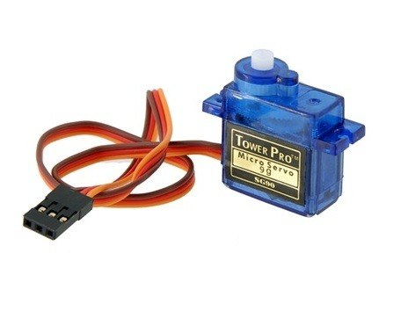

Figure 3.1 servomotor

Servo motors are used for various applications. They are normally small in size and have good energy efficiency. The servo circuitry is built inside the motor unit and comes with a positionable shaft that is fitted with a gear. The motor is controlled with an electric signal that determines the amount of shaft movement.

3.1.1 Components of the servo motor:
Inside the servo there are three main components; a small DC motor, a potentiometer and a control circuit. Gears are used to attach the motor to the control wheel. As the motor rotates, the resistance of the potentiometer changes so the control circuit can precisely regulate the amount of movement there is and the required direction. 21 When the shaft of the motor is at the desired position, power supply to the motor is stopped. If the shaft is not at the right position, the motor is turned in the right direction. The desired position is sent through electrical pulses via the signal wire. The speed of the motor is proportional to the difference between the actual position and the position that is desired. Therefore, if the motor is close to the desired position, it turns slowly. Otherwise, it turns fast.

3.1.2 How the servo is controlled:
Servos are sent through sending electrical pulses of variable width, or pulse width modulation (PWM), through the control wire. There is a minimum pulse, maximum pulse and a respetition rate. Servos can usually turn only 90 degrees in either direction for a total of 180 degrees movement. The neutral position of the motor is defined as that where the servo has the same amount of potential rotation in both the clockwise and counter-clockwise direction. The PWM sent to the motor determines the position of the shaft, and based on the duration of the pulse sent through the control wire the rotor will turn to the position that is desired. The servo motor expects to see a pulse after every 20 milliseconds and the length of the pulse will determine how far the motor will turn. For instance, a 1.5ms pulse makes the motor to turn in the 90 degrees position. If the pulse was shorter than 1.5ms,it will move to 0 degrees and a longer pulse moves it to 180 degrees. This is shown below.
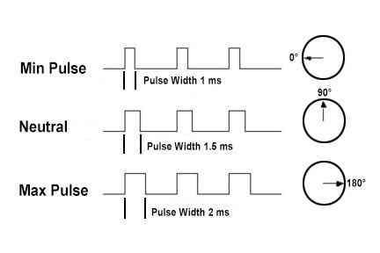

Figure 3.2: variable pulse width control servo position

For applications where there is requirement of high torque, servos are preferable. They will also maintain the torque at high speeds, up to 90% of the rated torque is available from servos at high speeds. Their efficiencies are between 80 to 90%.
A servo is able to supply approximately twice their rated torque for short periods of time, offering enough capacity to draw from when needed. In addition, they are quiet, are available in AC and DC, and do not suffer from vibrations.

3.1.3 Advantages and disadvantages of servo motors:
For applications where high speed and high torque are required, servo motors are the better option. While stepper motors peak at around 2000 RPM, servos are available at much faster speeds. Servo motors also maintain torque at high speed, up to 90% of the rated torque is available from servos at high speeds. They have an efficiency of about 80-90% and supply roughly twice their rated torque for short periods. Furthermore, they do not vibrate or suffer from resonance issues.
Servo motors are more expensive than other types of motors. Servos require gear boxes, especially for lower operation speeds. The requirement for a gear box and position encoder makes the designs more mechanically complex. Maintenance requirements will also increase.

3.2 Light Dependent Resistor :
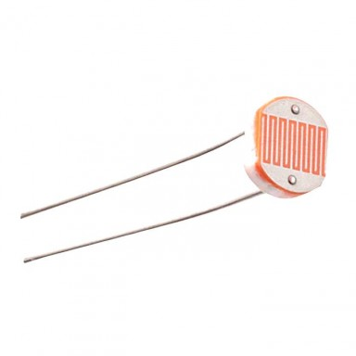

Figure 3.3: Light Dependent Resistor
The simplest optical sensor is a photon resistor or photocell which is a light sensitive resistor these are made of two types, cadmium sulfide (CdS) and gallium arsenide (GaAs).The sun tracker system designed here uses two cadmium sulfide (CdS) photocells for sensing the light. The photocell is a passive component whose resistance is inversely proportional to the amount of light intensity directed towards it. It is connected in series with capacitor. The photocell to be used for the tracker is based on its dark resistance and light saturation resistance.
The term light saturation means that further increasing the light intensity to the CdS cells will not decrease its resistance any further. Light intensity is measured in Lux, the illumination of sunlight is approximately 30,000 lux . Normally the resistance of an LDR is very high, sometimes as high as 1000K ohms, but when they are illuminated with light resistance drops dramatically. When the light level is low the resistance of the LDR is high. This prevents current from flowing to the base of the transistors. Consequently the LED does not light. However, when light shines onto the LDR its resistance falls.

3.2.1 Working Principle of LDR:

A light dependent resistor works on the principle of photo conductivity. Photo conductivity is an optical phenomenon in which the materials conductivity is increased when light is absorbed by the material. When light falls i.e. when the photons fall on the device, the electrons in the valence band of the semiconductor material are excited to the conduction band. These photons in the incident light should have energy greater than the band gap of the semiconductor material to make the electrons jump from the valence band to the conduction band. Hence when light having enough energy strikes on the device, more and more electrons are excited to the conduction band which results in large number of charge carriers. The result of this process is more and more current starts flowing through the device when the circuit is closed and hence it is said that the resistance of the device has been decreased.
3.2.2 Characteristics of LDR:

LDR’s are light dependent devices whose resistance is decreased when light falls on them and that is increased in the dark. When a light dependent resistor is kept in dark, its resistance is very high. This resistance is called as dark resistance. It can be as high as 10¹² Ω and if the device is allowed to absorb light its resistance will be decreased drastically.
If a constant voltage is applied to it and intensity of light is increased the current starts increasing. Figure below shows resistance vs. illumination curve for a particular LDR.
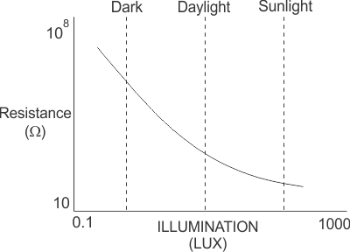

Figure3.4: Characteristics of LDR

Photocells or LDR’s are non linear devices. There sensitivity varies with the wavelength of light incident on them. Some photocells might not at all response to a certain range of wavelengths. Based on the material used different cells have different spectral response curves. When light is incident on a photocell it usually takes about 8 to 12 ms for the change in resistance to take place, while it takes one or more seconds for the resistance to rise back again to its initial value after removal of light. This phenomenon is called as resistance recovery rate. This property is used in audio compressors.
Also, LDR’s are less sensitive than photo diodes and phototransistor (A photo diode and a photocell (LDR) are not the same, a photo-diode is a PN junction semiconductor device that converts light to electricity, whereas a photocell is a passive device, there is no PN in this nor it “converts” light to electricity).

Photocell Resistance Testing Data:

Measured Resistance | Comment
50 KΩ | Dark light conditions (black vinyl tape placed over cell)
4.35 KΩ | Average light conditions (normal room lighting level)
200 Ω | Bright light conditions (flashlight directly in front of cell)

Table 3.1 Photocell resistance data

3.2.3 Applications of LDR:
LDR’s have low cost and simple structure. They are often used as light sensors. They are used when there is a need to detect absences or presences of light like in a camera light meter. Used in street lamps, alarm clock, burglar alarm circuits, light intensity meters, for counting the packages moving on a conveyor belt, etc.

3.3 SOLAR PANEL:
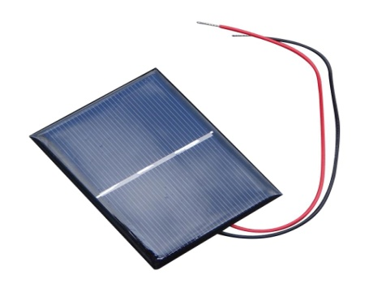

Figure3.5: solar panel

A solar tracker is a device used for orienting a photovoltaic array solar panel or for concentrating solar reflector or lens toward the sun. The position of the sun in the sky is varied both with seasons and time of day as the sun moves across the sky. Solar powered equipment work best when they are pointed at the sun. Therefore, a solar tracker increases how efficient such equipment are over any fixed position at the cost of additional complexity to the system. There are different types of trackers. Extraction of usable electricity from the sun became possible with the discovery of the photoelectric mechanism and subsequent development of the solar cell. The solar cell is a semiconductor material which converts visible light into direct current. Through the use of solar arrays, a series of solar cells electrically connected, there is generation of a DC voltage that can be used on a load. There is an increased use of solar arrays as their efficiencies become higher. They are especially popular in remote areas where there is no connection to the grid. Photo voltaic energy is that which is obtained from the sun. A photovoltaic cell, commonly known as a solar cell, is the technology used for conversion of solar directly into electrical power. The photovoltaic cell is a non mechanical device made of silicon alloy
.

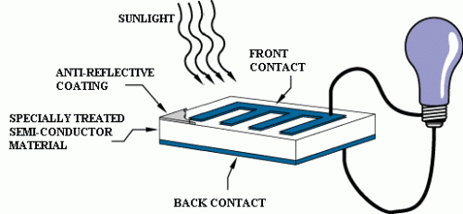

Figure 3.6:solar cell
The photovoltaic cell is the basic building block of a photovoltaic system. The individual cells can vary from 0.5 inches to 4 inches across. One cell can however produce only 1 or 2 watts that is not enough for most appliances. Performance of a photovoltaic array depends on sunlight. Climatic conditions like clouds and fog significantly affect the amount of solar energy that is received by the array and therefore its performance. Most of the PV modules are between 10 and 20 percent efficient.
3.4 ARDUINO UNO

3.4.1 DEFINITION
Arduino is an open-source electronics platform based on easy-to-use hardware and software. Arduino boards are able to read inputs - light on a sensor, a finger on a button, or a Twitter message - and turn it into an output - activating a motor, turning on an LED, publishing something online. To do so you use the Arduino programming language (based on Wiring), and the Arduino Software (IDE), based on Processing. Over the years Arduino has been the brain of thousands of projects, from everyday objects to complex scientific instruments. A worldwide community of makers - students, hobbyists, artists, programmers, and professionals - has gathered around this open-source platform, their contributions have added up to an incredible amount of accessible knowledge that can be of great help to novices and experts alike. Arduino was born at the Ivrea Interaction Design.

Institute as an easy tool for fast prototyping, aimed at students without a background in electronics and programming. As soon as it reached a wider community, the Arduino board started changing to adapt to new needs and challenges, differentiating its offer from simple 8-bit boards to products for IoT applications, wearable, 3D printing, and embedded environments. All Arduino boards are completely open-source, empowering users to build them independently and eventually adapt them to their particular needs. The software, too, is open-source, and it is growing through the contributions of users worldwide.

3.4.2 PRODUCT OVERVIEW
The Arduino Uno is a microcontroller board based on the ATmega328 (datasheet). It has 14 digital input/output pins (of which 6 can be used as PWM outputs), 6 analog inputs, a 16 MHz crystal oscillator, a USB connection, a power jack, an ICSP header, and a reset button. It contains everything needed to support the microcontroller; simply connect it to a computer with a USB cable or power it with a AC-to-DC adapter or battery to get started. The Uno differs from all preceding boards in that it does not use the FTDI USB-to-serial driver chip. Instead, it features the Atmega8U2 programmed as a USB-to-serial converter. "Uno" means one in Italian and is named to mark the upcoming release of Arduino 1.0. The Uno and version 1.0 will be the reference versions of Arduino, moving forward. The Uno is the latest in a series of USB Arduino boards, and the reference model for the Arduino platform; for a comparison with previous versions, see the index of Arduino boards.

3.4.3 SUMMARY
Arduino | ATmega328
Operating Voltage | 5V
Input Voltage (recommended) | 7-12V
Input Voltage (limits) | 6-20V
Digital I/O Pins | 14 (of which 6 provide PWM output)
Analog Input Pins | 6
DC Current per I/O Pin | 40Ma
DC Current for 3.3V Pin | 50Ma
Flash Memory | 32 KB of which 0.5 KB used by bootloader
SRAM | 2KB
EEPROM | 1KB
Clock Speed | 16MHz

Table 3.2 Components And Specification
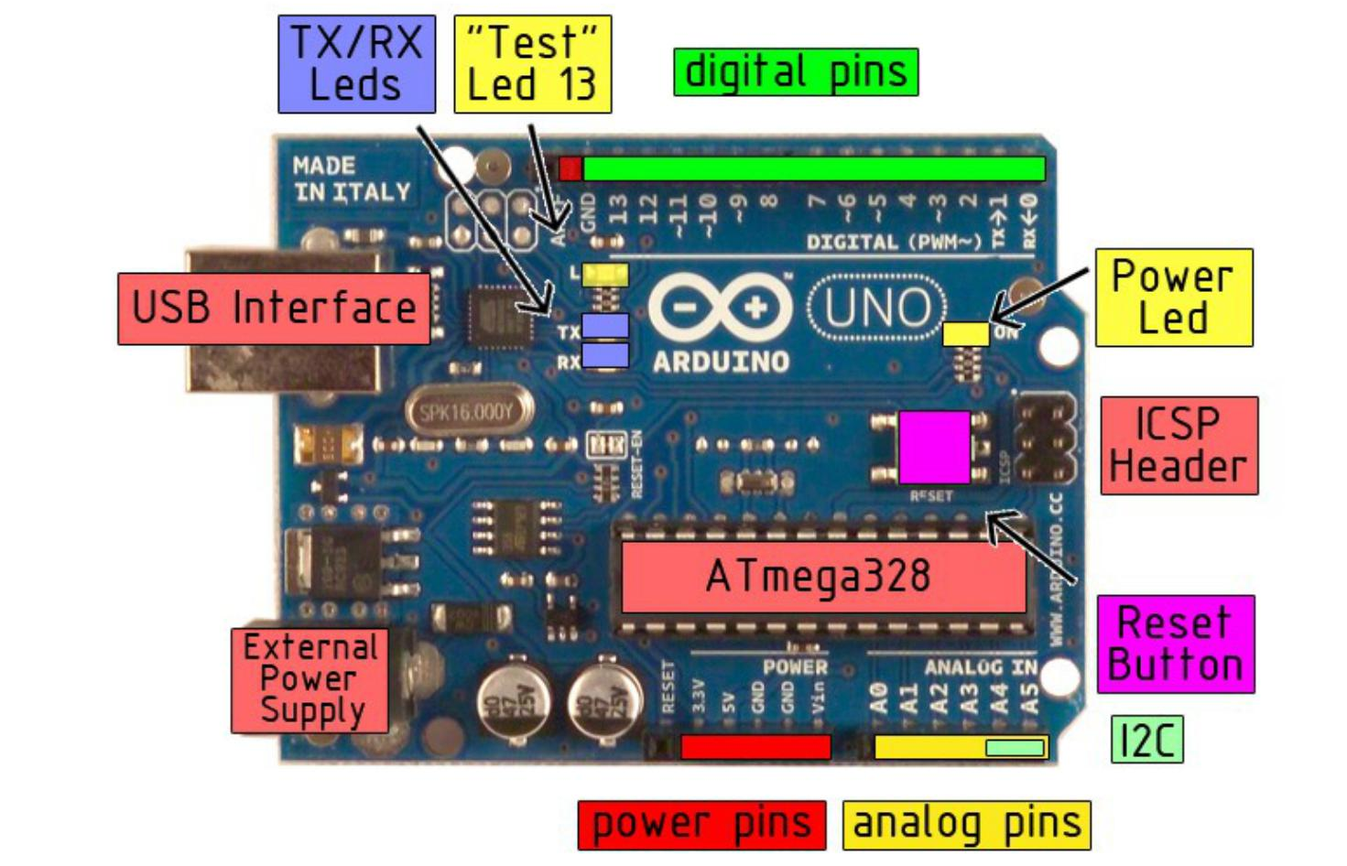

Figure 3.7: ARDUINO BOARD
3.4.4 POWER
The Arduino Uno can be powered via the USB connection or with an external power supply. The power source is selected automatically.
External (non-USB) power can come either from an AC-to-DC adapter (wall- wart) or battery. The adapter can be connected by plugging a 2.1mm center-positive plug into the board's power jack. Leads from a battery can be inserted in the Gnd and Vin pin headers of the POWER connector.
The board can operate on an external supply of 6 to 20 volts. If supplied with less than 7V, however, the 5V pin may supply less than five volts and the board may be unstable. If using more than 12V, the voltage regulator may overheat and damage the board. The recommended range is 7 to 12 volts. The power pins are as follows:
- VIN. The input voltage to the Arduino board when it's using an external power source (as opposed to 5 volts from the USB connection or other regulated power source). You can supply voltage through this pin, or, if supplying voltage via the power jack, access it through this pin.

- 5V. the regulated power supply used to power the microcontroller and other components on the board. This can come either from VIN via an on-board regulator, or be supplied by USB or another regulated 5V supply.

- 3.3V A 3.3 volt supply generated by the on-board regulator. Maximum current draw is 50 mA.

- GND. Ground pins

3.4.5 MEMORY
The Atmega328 has 32 KB of flash memory for storing code (of which 0,5 KB is used for the boot loader It has also 2 KB of SRAM and 1 KB of EEPROM (which can be read and written with the EEPROM library).
3.4.6 INPUT AND OUTPUT
Each of the 14 digital pins on the Uno can be used as an input or output, using pinMode(), digitalWrite(), and digitalRead() functions. They operate at 5 volts. Each pin can provide or receive a maximum of 40 mA and has an internal pull-up resistor (disconnected by default) of 20-50 kOhms. In addition, some pins have specialized functions:
- Serial: 0 (RX) and 1 (TX). Used to receive (RX) and transmit (TX) TTL serial data. TThese pins are connected to the corresponding pins of the ATmega8U2 USB-to-TTL Serial chip .
- External Interrupts: 2 and 3. These pins can be configured to trigger an interrupt on a low value, a rising or falling edge, or a change in value. See the attachInterrupt() function for details.
- PWM: 3, 5, 6, 9, 10, and 11. Provide 8-bit PWM output with the analogWrite() function.
- SPI: 10 (SS), 11 (MOSI), 12 (MISO), 13 (SCK). These pins support SPI communication, which, although provided by the underlying hardware, is not currently included in the Arduino language.
- LED: 13. There is a built-in LED connected to digital pin 13. When the pin is HIGH value, the LED is on, when the pin is LOW, it's off.

The Uno has 6 analog inputs, each of which provide 10 bits of resolution (i.e. 1024 different values). By default they measure from ground to 5 volts, though is it possible to change the upper end of their range using the AREF pin and the analogReference() function. Additionally, some pins have specialized functionality:
- I2C: 4 (SDA) and 5 (SCL). Support I2C (TWI) communication using the Wire library. There are a couple of other pins on the board.
- AREF. Reference voltage for the analog inputs. Used with analogReference().
- Reset. Bring this line LOW to reset the microcontroller. Typically used to add a reset button to shields which block the one on the board.

3.4.7 COMMUNICATION
The Arduino Uno has a number of facilities for communicating with a computer, another Arduino, or other microcontrollers. The ATmega328 provides UART TTL (5V) serial communication, which is available on digital pins 0 (RX) and 1 (TX).
An ATmega8U2 on the board channels this serial communication over USB and appears as a virtual com port to software on the computer. The '8U2 firmware uses the standard USB COM drivers, and no external driver is needed. However, on Windows, an *.inf file is required..
Arduino software includes a serial monitor which allows simple textual data to be sent to and from the Arduino board. The RX and TX LEDs on the board will flash when data is being transmitted via the USB-to-serial chip and USB connection to the computer (but not for serial communication on pins 0 and 1).A Software Serial library allows for serial communication on any of the Uno's digital pins. The ATmega328 also support I2C (TWI) and SPI communication. The Arduino software includes a Wire library to simplify use of the I2C bus; see the documentation for details. To use the SPI communication, please see the ATmega328 datasheet.

3.4.8 PROGRAMMING
The Arduino Uno can be programmed with the Arduino software (download). Select "Arduino Uno w/ ATmega328" from the Tools > Board menu (according to the microcontroller on your board). For details, see the reference and tutorials.

The ATmega328 on the Arduino Uno comes preburned with a boot loader that allows you to upload new code to it without the use of an external hardware programmer. It communicates using the original STK500 protocol (reference, C header files).

You can also bypass the boot loader and program the microcontroller through the ICSP (In-Circuit Serial Programming) header; see these instructions for details.

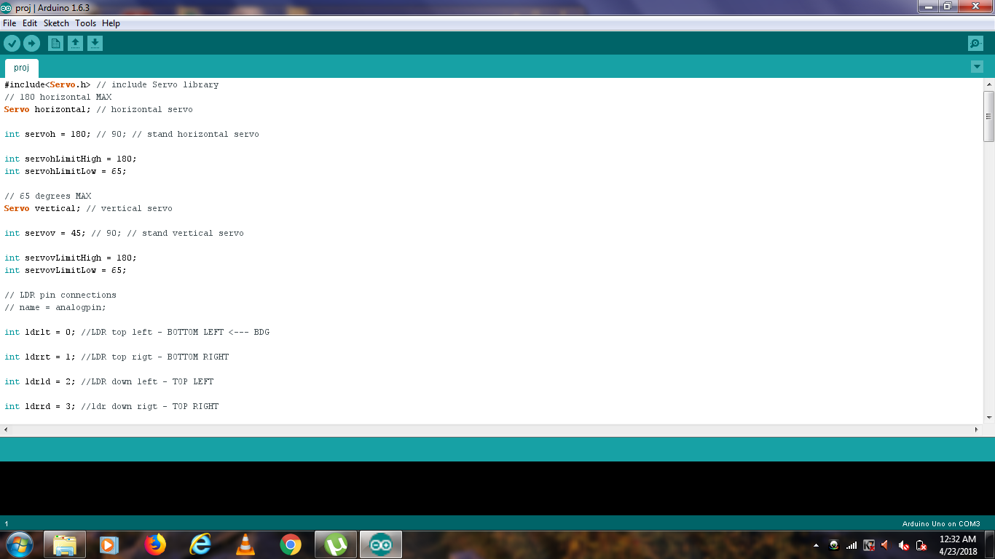
.2.1.9 DIMENSION DRAWING
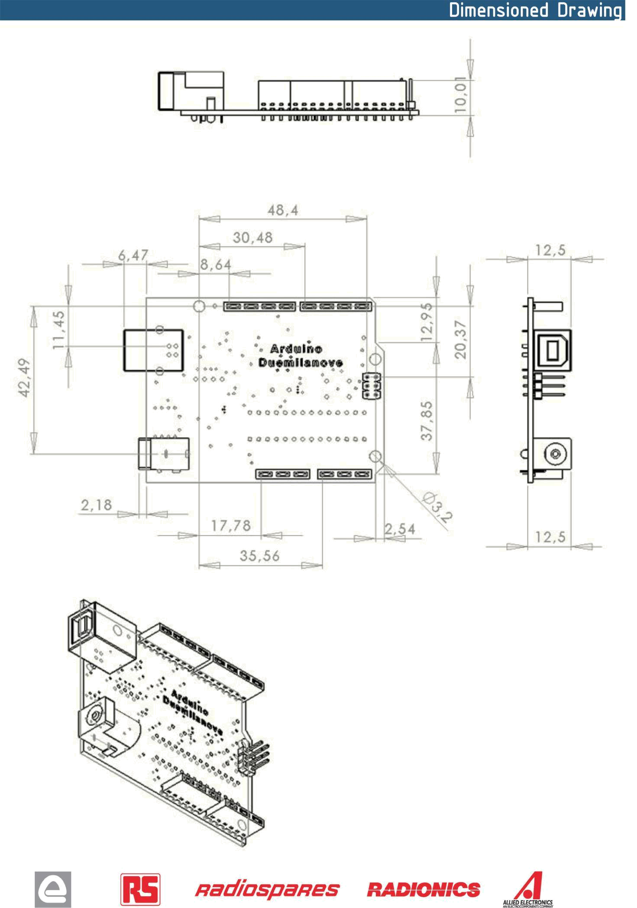
Figure 3.8: DIMENSION DRAWING

Chapter Four: Design and Working

4.1 Algorithm for Motor Control
The algorithm gives the description of the general steps undertaken for the project:
1. There is input of the voltages from the four LDRs.
2 . The inputs are analog. They are converted to digital values that range between 0-1023.
3. The four digital values are top, bottom, right and left .
4. The average of top (Both left and right) and bottom values are calculated.
5. The Servo motor moves in the direction of the LDR having maximum intensity.

4.2 WORKING
The four LDR’s are connected to the analog pins A0, A1, A2, A3 of the Arduino Uno micro controller. The servo motor is connected to the digital pins 10 and 11 of the arduino. LDRs are used as the main light sensors. Two servo motors are fixed to the structure that holds the solar panel. The program for Arduino is uploaded to the microcontroller. The working of the project is as follows.

- LDRs sense the amount of sunlight falling on them. Four LDRs are divided into top, bottom, left and right.
- For east – west tracking, the analog values from two top LDRs and two bottom LDRs are compared and if the top set of LDRs receive more light, the vertical servo will move in that direction.
- If the bottom LDRs receive more light, the servo moves in that direction.

- For angular deflection of the solar panel, the analog values from two left LDRs and two right LDRs are compared. If the left set of LDR’s receive more light than the right set, the horizontal servo will move in that direction.
- If the right set of LDR’s receive more light, the servo moves in that direction.
  - BLOCK DIAGRAM
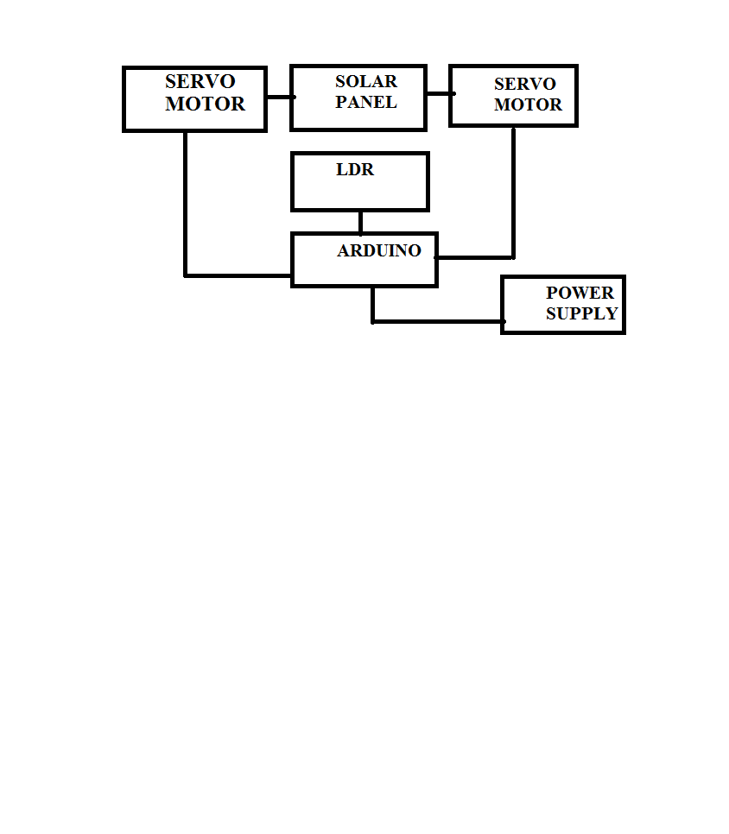
Figure 3.9 Block diagram
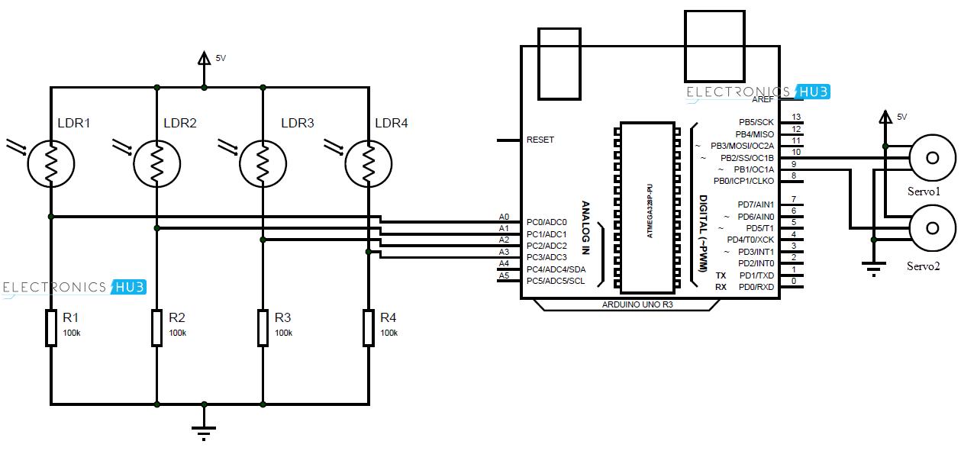
4.4 CIRCUIT DIAGRAM
Figure 3.10: circuit diagram

4.5 SCHEMATIC DIAGRAM OF HARDWARE

The Simulation of the hardware is done by using the software tool Proteus 8 Professional. The Schematic diagram of the hardware model in Proteus is given below,

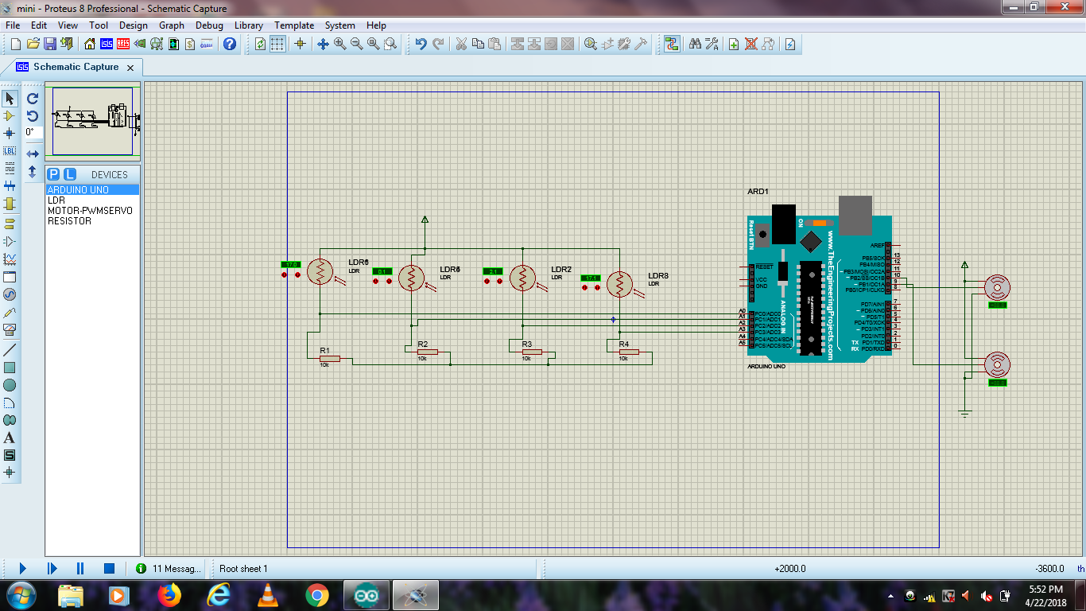

Figure 3.11: SCHEMATIC DIAGRAM OF HARDWARE

4.6 Final Module
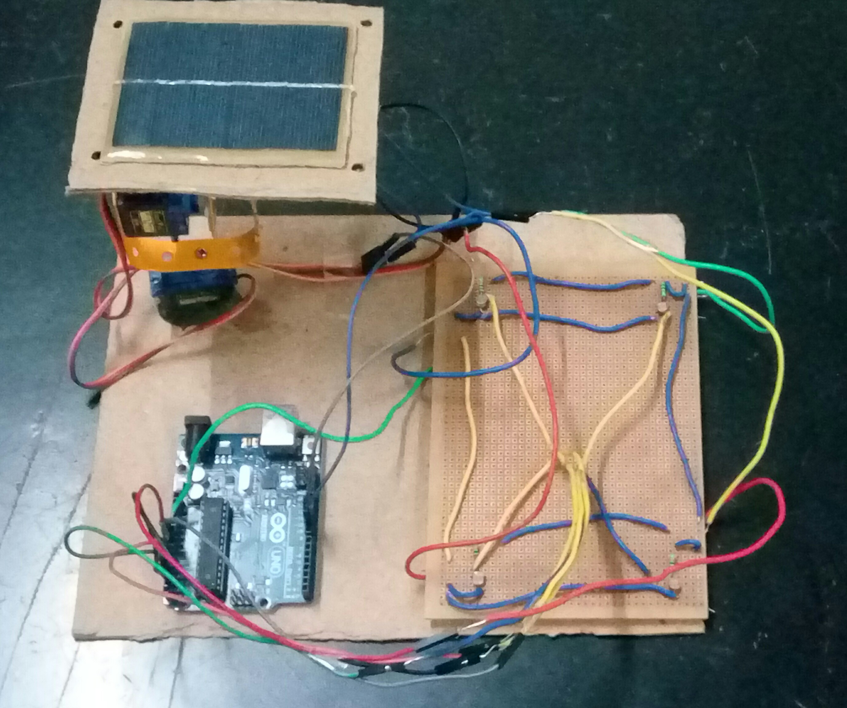

CHAPTER 5: DISCUSSION, CONCLUSION AND FUTURE WORK
5.1 Discussion
The objective of the project was to design a system that tracks the sun for a solar panel. This was achieved through using light sensors that are able to detect the amount of sunlight that reaches the solar panel. The values obtained by the LDRs are compared and if there is a significant difference, there is actuation of the panel using a servo motor to the point where it is almost perpendicular to the rays of the sun. This was achieved using a system with three stages or subsystems.
Each stage has its own role. The stages were,
- A control stage that was responsible for controlling actuation and decision making
- A driver stage with the servo motor. It was responsible for actual movement of the panel.
The LDRs were found to be most suitable for this project because their resistance varies with light. They are readily available and are cost effective. Temperature sensors for instance would be costly. The control stage has a microcontroller that receives voltages from the LDRs and determines the action to be performed. The microcontroller is programmed to ensure it sends a signal to the servo motor that moves in accordance with the generated error. The final stage was the driving circuitry that consisted mainly of the servo motor. The servo motor had enough torque to drive the panel. Servo motors are noise free and are affordable, making them the best choice for the project.

5.2 Conclusion
A solar panel that tracks the sun was designed and implemented. The required program was written that specified the various actions required for the project to work. As a result, tracking was achieved. Dual axis trackers are more efficient in tracking the sun, the additional circuitry and complexity was not required in this case. Dual trackers are most suitable in regions where there is a change in the position of the sun. This project was implemented with minimum resources. The circuitry was kept simple, while ensuring efficiency is not affected.
5.3 Future work
The project is able to be implemented on a much larger scale. For future projects, one may consider the use of more efficient sensors, but which are cost effective and consume little power. This would further enhance efficiency while reducing costs. If there is the possibility of further reducing the cost of this project, it would help a great deal. Before the solar tracker and light pipe could be placed on a roof for long periods of time, they both must be sealed and waterproof. The motors and circuitry must be protected from rain and snow
Shading has adverse effects on the operation of solar panels.
Shading of a single cell will have an effect on the entire panel because the cells are usually connected in series. With shading therefore, the tracking system will not be able to improve efficiency as is required.
Also in night time there is no sun’s radiation so we does not want it to work in night time and also in the rainy season. So for future work if there is no sunlight or in cloudy conditions or in rainy season the module automatically turns off and saves the power consumption of the solar tracker. So for future work if the LDR sensor value is lower than the critical value we can made it to turn off automatically.
REFERENCE

Arduino based low cost active dual axis solar tracker
Tarlochan Kaur; Shraiya Mahajan; Shilpa Verma; Priyanka; Jaimala Gambhir
2016 IEEE 1st International Conference on Power Electronics, Intelligent Control and Energy Systems (ICPEICES) Year: 2016
Dual-axis solar tracker based on predictive control algorithms A. K. Suria; R. Mohamad Idris 2015 IEEE Conference on Energy Conversion (CENCON) Year: 2015

Novel Online Sensorless Dual-Axis Sun Tracker
Hassan Fathabadi IEEE/ASME Transactions on Mechatronics Year: 2017

Direct and indirect sensing two-axis solar tracking system
Falah I. Mustafa; A. Salam Al-Ammri; Farouk F. Ahmad
2017 8th International Renewable Energy Congress (IREC) Year: 2017

Sun tracking schemes for photovoltaic panels
Marzia Hoque Tania; Md. Samiul Alam 2014 3rd International Conference on the Developments in Renewable Energy Technology (ICDRET) Year: 2014

APPENDICES

Appendix one: Code for tracking system
#include<Servo.h>
int servoh = 180;
int servohLimitHigh = 180;
int servohLimitLow = 65;
int servov = 45;
int servovLimitHigh = 80;
int servovLimitLow = 15;
// LDR pin connections
int ldrlt = 0; //LDR top left - BOTTOM LEFT
int ldrrt = 1; //LDR top right - BOTTOM RIGHT
int ldrld = 2; //LDR down left - TOP LEFT
int ldrrd = 3; //LDR down right - TOP RIGHT
void setup()
{
Serial.begin(9600);
// servo connections
horizontal.attach(9); // name.attacht(pin);
vertical.attach(10);
horizontal.write(180);
vertical.write(45);
delay(3000);}
void loop()
{
int lt = analogRead(ldrlt); // top left
int rt = analogRead(ldrrt); // top right
int ld = analogRead(ldrld); // down left
int rd = analogRead(ldrrd); // down right
int avt = (lt + rt) / 2; // average value top
int avd = (ld + rd) / 2; // average value down
int avl = (lt + ld) / 2; // average value left
int avr = (rt + rd) / 2; // average value right
if (avt > avd)
{
servov = ++servov;
if (servov > servovLimitHigh)
{
servov = servovLimitHigh;
}
}
else if (avt < avd)
{
servov= --servov;
if (servov < servovLimitLow)
{
servov = servovLimitLow;
}
}
vertical.write(servov);
}
if (avl > avr)
{
servoh = --servoh;
if (servoh < servohLimitLow)
{
servoh = servohLimitLow;
}
}
else if (avl < avr)
{
servoh = ++servoh;
if (servoh > servohLimitHigh)
{
servoh = servohLimitHigh;
}
}
else if (avl = avr)
{
// nothing
}
horizontal.write(servoh);
}
}

Appendix two: code used to measure LDR values

int ldr1=0;
int ldr2=0;
int ldr3=0;
int ldr4=0;
void setup()
{
Serial. begin(9600);
Ldr1value=analog.Read(ldr1);
Ldr2value=analog.Read(ldr2);
Ldr3value=analog.Read(ldr3);
Ldr4value=analog.Read(ldr4);
}
Void loop()
{
Serial.Println(ldrvalue1);
delay(1000);
Serial.Println(ldrvalue2);
delay(1000);
Serial.Println(ldrvalue3);
delay(1000);
Serial.Println(ldrvalue4);
delay(1000);
}

